

NAME: Rutuja Kharode
REGISTRATION NO.: 25BCE10605
BRANCH: Computer Science Engineering (CSE core)
COURSE: Digital Literacy
COURSE CODE: CSE0001
YEAR: 1st Year (2nd semester)
DATE: 30 March 2026

SCENARIO

You have just been selected as a Student Digital Ambassador at your college. Your role is to help your peers navigate the digital world — from creating professional online profiles, to communicating safely and responsibly online. Your first assignment is to build a Digital Literacy Portfolio that you will present to the faculty committee and share with your batch.

INTRODUCTION

If I’m being honest, most of our day is spent online in one way or another—attending classes, submitting assignments, texting friends, or just scrolling for a break. We use the internet so naturally that we don’t always stop and think about how we’re using it, or whether we’re doing it safely and smartly. That’s exactly what made this project feel important to me.
As a Student Digital Ambassador, this is my first step towards helping my classmates become a little more aware and confident in the digital world. I didn’t want this portfolio to feel like a boring, textbook-style project. Instead, I tried to keep it simple, relatable, and based on real situations that we all go through as students.
In this portfolio, I’ve included a mix of things we actually need in our daily lives—like a basic awareness infographic, a student digital portfolio to present ourselves better online, some useful coding and collaboration platforms, a guide to writing proper emails (because we’ve all been confused about that at some point), and a cybercrime case study with practical safety tips.
The main idea behind all of this is not to make anyone an expert overnight, but just to build small, smart habits. Because sometimes, knowing a few simple things can save us from big mistakes online.

Task 1: Create a Digital Literacy Awareness Infographic
For this task, I created my infographic using Canva. I chose Canva because it’s simple to use and honestly makes designing feel less stressful, even if you’re not very experienced. I wanted my design to look something that my classmates would actually stop and read, not just scroll past.
In the infographic, I focused on explaining digital literacy in a way that feels real and relatable—not just a definition, but something we use every day while studying, searching, or communicating online. I also added a section on useful digital tools that can help students stay organized, improve their work, and learn new things. Along with that, I included some basic but important internet safety tips, like using strong passwords, being careful with links, and protecting personal information.
What I found most interesting was how much difference small things like icons, colors, and layout can make. At first, I kept changing the design because either it looked too plain or too crowded. That was probably the most challenging part—keeping it clean but still informative. Overall, this task made me realize that presenting information in a simple and attractive way actually makes people more likely to understand and remember it.

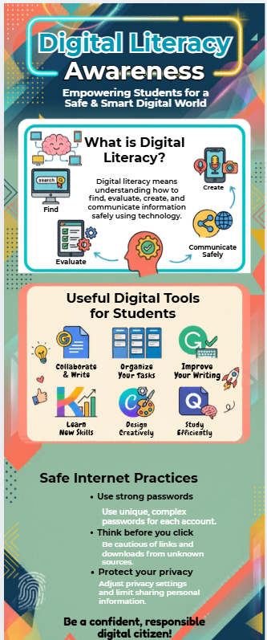
Above is the infographic made by me using CANVA for digital literacy awareness
LINK: https://www.canva.com/design/DAHFTO1_Aiw/dKfBLB-2JcG2zgFPDtULbg/edit?utm_content=DAHFTO1_Aiw&utm_campaign=designshare&utm_medium=link2&utm_source=sharebutton
Task 2: Build Your Student Digital Portfolio
For this task, I created my profiles on LinkedIn, GitHub, and Kaggle. I chose these platforms because I’ve heard a lot about how important they are for students, especially when it comes to internships and future careers, so I wanted to start early.
While working on LinkedIn, I filled in my education details like my degree, college, and expected graduation year. It felt like I was slowly building my professional identity. On GitHub, I created my profile README where I introduced myself, added my branch and year, and wrote a small line about what I want to learn in the future. It made me feel like I finally have a space to showcase my work, even if I’m just starting. On Kaggle, I explored some datasets and notebooks, which gave me a basic idea of how people actually work with data.
Over the next four years, I plan to keep updating these profiles as I learn new things. I want to upload projects on GitHub, connect with people and explore opportunities through LinkedIn, and improve my skills by practicing more on Kaggle. It’s just a start, but it feels like a good one.

Following are the Profiles:

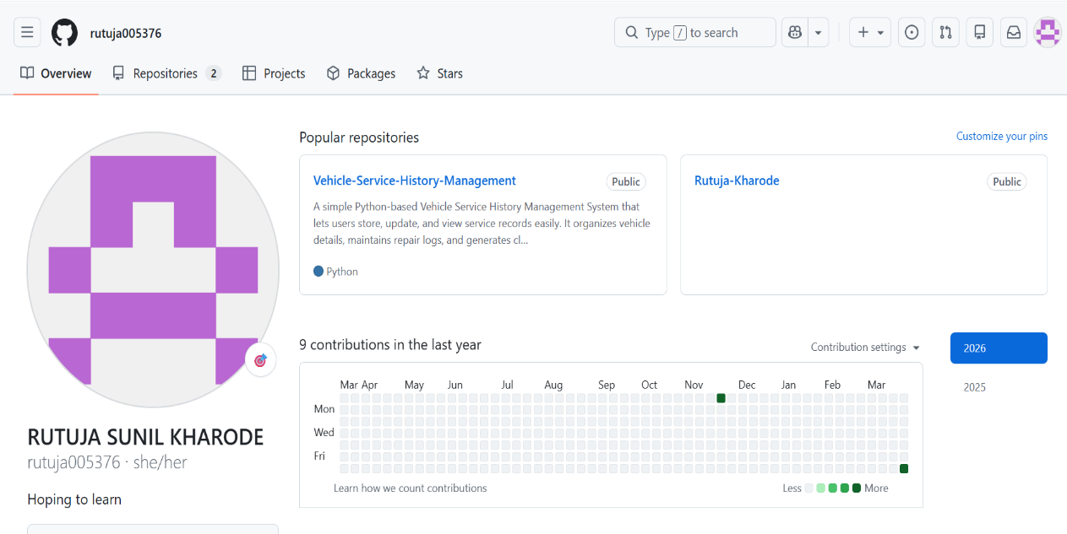

Above is the GitHub profile of mine which has been updated with a special Repository.
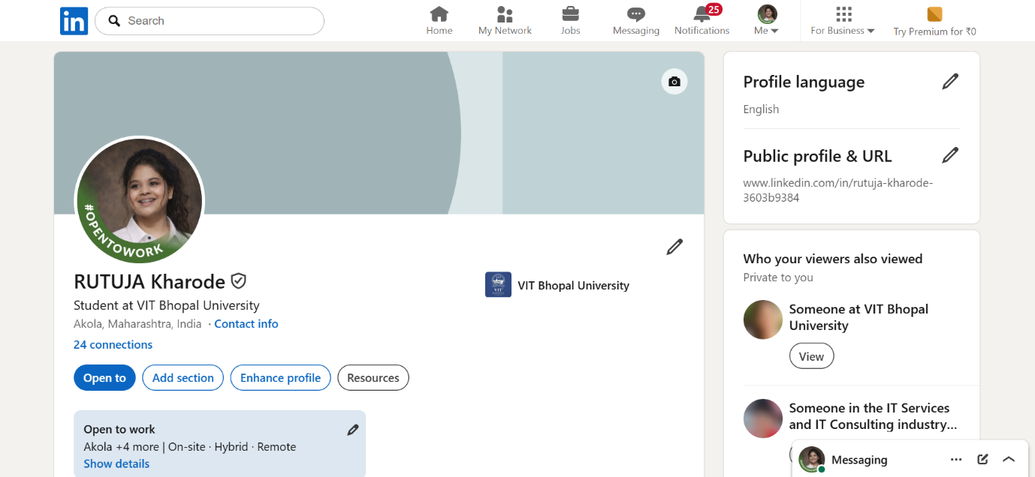

Above is the LinkedIn profile of mine which has been updated and educational details had been added.

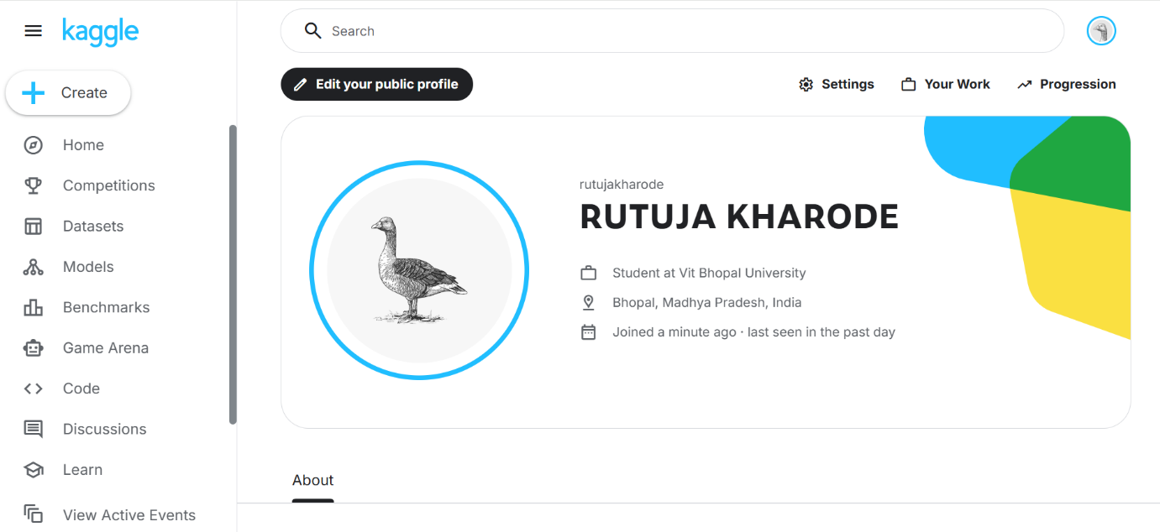

Above Kaggle account of mine which has been updated and I have explored its features.

Task 3: Explore Coding & Collaboration Platforms

Part A – Coding Practice
For this task, I explored HackerRank and tried solving a beginner-level problem called “Solve Me First.” Since I’m still new to coding, I didn’t want to jump into something too difficult. I just wanted to understand how these platforms actually work and get comfortable with the process.
At first, I was a little unsure about how everything works—like where to write the code and how to test it. But once I started, it became much easier to follow. After writing the solution and running it, seeing it passes the test cases felt really satisfying. It may be a small problem, but solving it on my own gave me a bit of confidence.
What I liked the most is how HackerRank gives instant feedback. If something is wrong, you can fix it immediately, which makes learning feel more practical instead of confusing.
I feel that practicing on platforms like this can really help me in the long run. It can improve my thinking, make me more comfortable with coding, and prepare me better for exams, projects, and even placements later on. It’s just a small start, but it feels like I’m moving in the right direction.

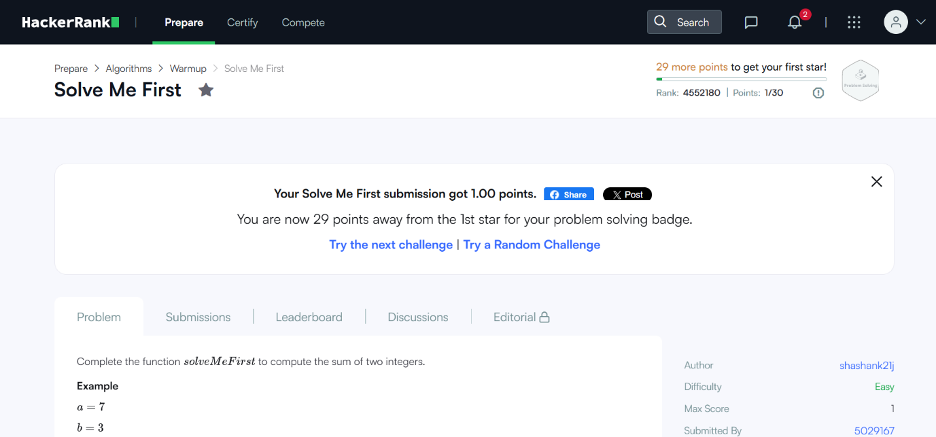

Part B – Google Workspace Collaboration
For this part of the task, I used Google Forms to create a Digital Literacy Awareness Quiz for my classmates. I kept the quiz short with exactly five questions so that it doesn’t feel boring or time-consuming. I included both multiple choice and a short answer question, and tried to frame everything in a way that feels simple and relatable to our daily online habits—like password safety, using the internet responsibly, and basic awareness.
While making the form, I realized it’s not just about adding questions, but also about how clearly you ask them. I had to think from a student’s perspective so that the questions are easy to understand and not confusing. After that, I connected the form to a Google Sheet, and it was actually interesting to see how all the responses get collected automatically in one place.
What I really liked about this task is how easy it is to create something useful that others can interact with. It doesn’t feel complicated, but it’s still very effective.
I feel tools like this will be really helpful in my academics, especially for surveys, collecting opinions, and working on group projects in a more organized way.

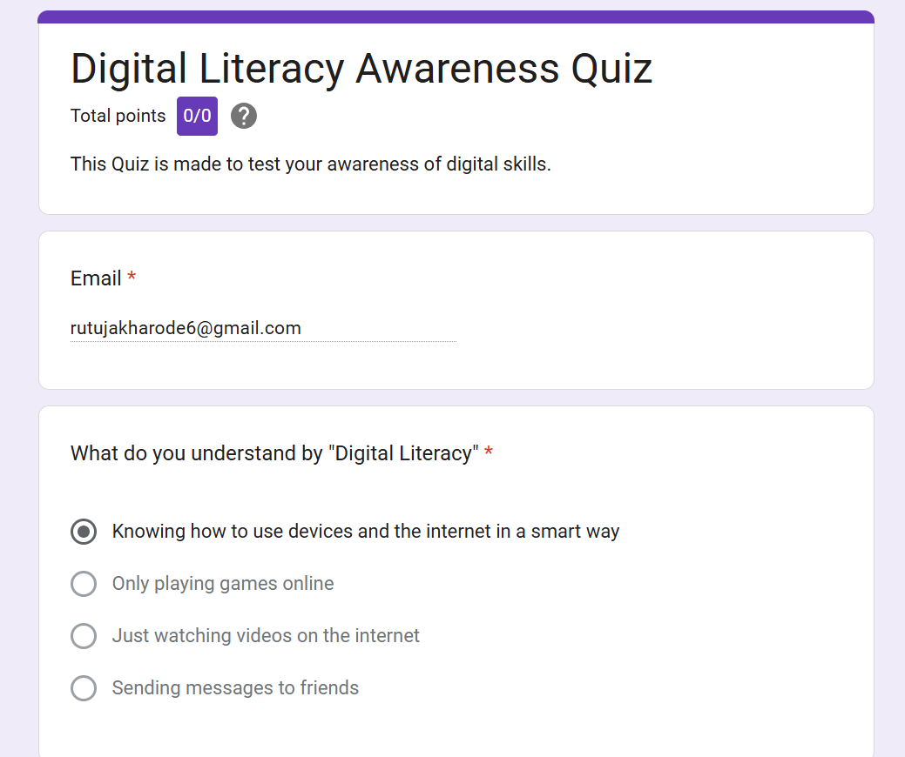

Task 4: Draft a Professional Email & Etiquette Guide

Honestly, most of us are so used to casual texting that we sometimes forget emails aren’t the same. A small mistake in how we write something online can actually create unnecessary problems. For example, imagine a student sending a message to a professor saying, “Send deadline ahead pls” or “I can’t submit, give extension,” without any proper subject, greeting, or explanation. From the student’s side, it might feel quick and normal, but to the professor, it can come across as careless or even a bit rude.
Because of this, the professor might ignore the email or not fully understand the situation, which can end up affecting the student’s grades.
The truth is, fixing this doesn’t require anything complicated. Just writing a proper subject, starting with a respectful greeting, explaining the reason clearly, and ending politely can change everything. It shows that you’re serious and respectful.
This made me realize that good digital communication is not about using difficult words—it’s just about being clear, polite, and a little more thoughtful in how we express ourselves online.

Task 5: Cybercrime Awareness Case Study & Prevention Guide

What honestly surprised me the most in this case is how normal everything felt in the beginning. There were no obvious warning signs—the buyer sounded polite, didn’t bargain, and everything seemed smooth and easy. It didn’t feel like a scam at all. That’s what made me realize that these situations don’t always look suspicious; sometimes they feel completely real, and that’s exactly how people get trapped.
After reading this, one habit I really want to change is reacting too quickly when it comes to online payments. Earlier, I might have just scanned a QR code or followed instructions without thinking much, especially if the other person seemed genuine. But now, I feel it’s really important to pause for a moment and think before doing anything.
This case made me understand that even a small action, like entering a UPI PIN without realizing, can lead to a big loss. So now, I just want to be more careful and not trust things online so easily.

Conclusion:
Looking back, this project turned out to be more useful than I expected. It wasn’t just about completing tasks—it actually made me think about how I use technology every day. I realized that digital literacy is not just about knowing apps or tools, but about using them in a smart and responsible way.
Each part of the project taught me something practical. Whether it was designing the infographic, creating my profiles, trying coding for the first time, writing proper emails, or understanding how online scams happen—it all felt connected to real life.
What stood out the most is how small things can make a big difference. Being careful while making online payments or writing a clear email might seem basic, but it really matters.
Overall, this experience made me more aware and a bit more confident while using digital platforms. As a Digital Ambassador, I feel like I can now guide others in a simple and practical way.

References:
- Canva – used for designing the infographic
- LinkedIn – used for creating a professional profile
- GitHub – used for building my portfolio
- Kaggle – used for exploring datasets
- HackerRank – used for coding practice
- Google Forms – used for creating the quiz and collecting responses
Along with these tools, I also used my basic understanding and what I’ve learned in class while working on this project.

